RINGWOOD TOWN COUNCIL
Regular Meeting - Ringwood Town Hall Monday, October 6, 2025
5:30 p.m.
Minutes Page One

The meeting was called to order by Mayor Brandi Goodman at 5:30 p.m.

Members Present: Brandi Goodman, Gina Bohlen, Sherry Davidson, Steve Randolph Members absent: Maxine Smith, Barbara Look
No public comments.

A motion was made by Gina Bohlen and seconded by Brandi Goodman approving the minutes of the September 8, 2025 regular meeting. The following votes were cast: Goodman - yes, Bohlen -yes, no nays.
TOWN CLERK/TREASURER REPORT: None

CODE ENFORCEMENT: None. Sherry reported that our first Municipal Court was held and was an immense success.
FIRE DEPARTMENT REPORT: None
STREET DEPARTMENT REPORT: See attached report by Steve Randolph. SHERIFF DEPARTMENT : None
NEW BUSINESS:
A motion was made by Gina Bohlen to approve the claims pursuant to the claims list. Brandi Goodman seconded the motion and the following votes were cast: Bohlen - yes, Goodman -yes, no nays.
Luanne Detrick, Major County Treasurer and Ryan Greb, Major County Commissioner, spoke to the board regarding the upcoming Sales Tax vote on November 18th. The tax is used for Major County Courthouse maintenance and repairs.
Brandi Goodman made a motion that was seconded by Gina Bohlen to approve Resolution 2025-07 amending the 2015 Capital Improvement Plan of the Town of Ringwood. The following votes were cast: Goodman - yes, Bohlen - yes, no nays.

Page2

Ringwood Town Council
Monday, October 6, 2025 Regular Meeting Ringwood Town Hall

A motion was made by Gina Bohlen to approve Resolution 2025-08 authorizing application for financial assistance from the Rural Economic Action Plan (REAP)
Fund for the Main Street Asphalt Overlay Project. Brandi Goodman seconded the motion and the following votes were cast: Bohlen - yes, Goodman - yes, no nays.

A discussion was held regarding the annual Christmas Lighting Contest. Brandi Goodman made a motion that was seconded by Gina Bohlen to approve and continue the contest with the same prizes as last year. The following votes were cast: Goodman - yes, Bohlen - yes, no nays.

A discussion was held regarding our windmill project. Sherry contacted the Major County Historical Society and they will be unable to repair the windmill that was donated. It was decided that we would table the windmill project until a later date.

OTHER NEW BUSINESS:

Sherry informed the board that we will need to have a special meeting as soon as our budget is received from the auditor.

A discussion was held regarding our annual Employee Christmas Party. It will be held on Friday, December 5th at the home of Mark and Sherry Davidson.

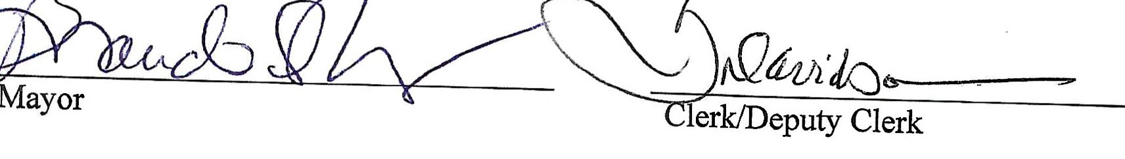
The meeting adjourned at 6:14 p.m.

Ringwood Town Council Special Board Meeting Minutes Friday, October 17, 2025
Ringwood Town Hall, 200 N. Main, Ringwood, OK 5:30 p.m.
The special meeting was called to order at 5:30 p.m. by Mayor Brandi Goodman.

Members present: Brandi Goodman, Barbara Look, Sherry Davidson, Maxine Smith

Members absent: Gina Bohlen

Brandi Goodman made a motion that was seconded by Barbara Look to approve the FY26 estimate of needs and financial reports. The following votes were cast: Goodman -yes, Look - yes, no nays.

The meeting adjourned at 5:45 p.m.

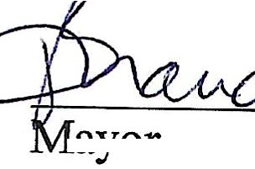
f

�
di ll:v---�v,JLo,
Treasurer/Deputy Treasurer

RINGWOOD PUBLIC WORKS AUTHORITY
Regular Meeting, Monday, October 6, 2025
200 N. Main, Ringwood, OK 73768

Meeting called to order by Mayor Brandi Goodman at 6:15 p.m., City Hall.
ROLL CALL:
Brandi Goodman Gina Bohlen Sherry Davidson Steve Randolph
Members absent: Barbara Look, Maxine Smith

There were no public comments.

A motion was made by Gina Bohlen and seconded by Brandi Goodman to approve the minutes of the September 8, 2025 regular meeting. The following votes were cast: Goodman - yes, Bohlen - yes, no nays.
CLERK/TREASURER REPORT: None
PUBLIC WORKS REPORT: Steve Randolph presented his report. Please see attached. NEW BUSINESS:
Brandi Goodman made a motion to approve the claims as listed on the claims list. Gina Bohlen seconded the motion and the following votes were cast: Goodman - yes, Bohlen -yes, no nays.

OTHER NEW BUSINESS:
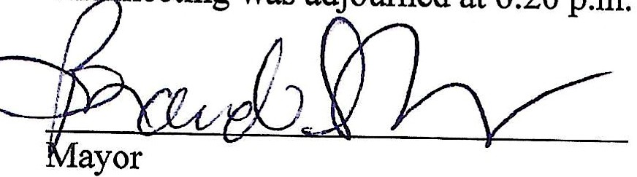
None

��&L/2h� Clerk/Deputy Clerk

