RINGWOOD TOWN COUNCIL
Regular Meeting - Ringwood Town Hall Monday, November 3, 2025
5:30 p.m.
Minutes Page One

The meeting was called to order by Mayor Brandi Goodman at 5:30 p.m.

Members Present: Brandi Goodman, Gina Bohlen, Barbara Look , Sherry Davidson, Steve Randolph, Brandon Harmon
Members absent: Maxine Smith Guest Present: Tony Robison, MCSO
No public comments.

A motion was made by Gina Bohlen and seconded by Brandi Goodman approving the minutes of the October 6, 2025 regular meeting and the October 17, 2025 Special Meeting. The following votes were cast: Goodman - yes, Bohlen - yes, Look - yes, no nays.

TOWN CLERK/TREASURER REPORT: None
CODE ENFORCEMENT: None. Sherry reported that Brian will be performing Life Safety Inspections this month.
FIRE DEPARTMENT REPORT: Brandon Harmon provided the board with a report. STREET DEPARTMENT REPORT: See attached report by Steve Randolph.
SHERIFF DEPARTMENT : Tony Robison provided the board with a report. NEW BUSINESS:
A motion was made by Barbra Look to approve the claims pursuant to the claims list. Gina Bohlen seconded the motion and the following votes were cast: Bohlen - yes, Goodman - yes, Look - yes, no nays.
Brandi Goodman made a motion to sign and approve the contract with Cory Spomer on the property donation. Barbara Look seconded the motion and the following votes were cast: Goodman - yes, Bohlen - yes, Look - yes, no nays.

A discussion was held regarding the rental property on Main Street. Sherry will keep the board posted on any updates she receives from Brock Bishop.

Page2
Ringwood Town Council
Monday, November 3, 2025 Regular Meeting Ringwood Town Hall

A motion was made by Brandi Goodman and seconded by Gina Bohlen to approve the renewal of the contract with Country Technology Solutions for one year. The following votes were cast: Goodman - yes, Bohlen - yes, Look - yes, no nays.

Gina Bohlen made a motion to approve and sign the Grant writer engagement letter with Five Tool Management for Ringwood Fire. Barbara Look seconded the motion and the following votes were cast: Bohlen - yes, Look - yes , Goodman - yes, no nays.

A discussion was held regarding our upcoming Town of Ringwood Christmas party. It will be held on December 5th, 2025 at the home of Mark and Sherry Davidson.
OTHER NEW BUSINESS:

None.

The meeting adjourned at 6:05 p.m.
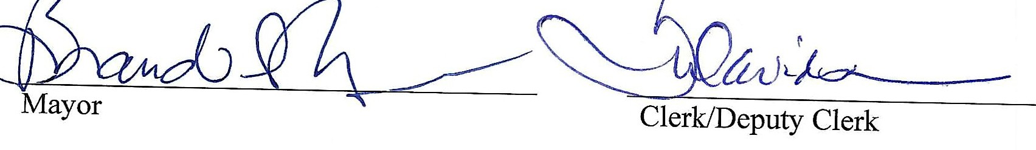

RINGWOOD PUBLIC WORKS AUTHORITY
Regular Meeting, Monday, November 3, 2025
200 N. Main, Ringwood, OK 73768

Meeting called to order by Mayor Brandi Goodman at 6:05 p.m., City Hall.

ROLL CALL:
Brandi Goodman Gina Bohlen Barbara Look Sherry Davidson Steve Randolph Brandon Harmon
Members absent: Maxine Smith Guest: Tony Robison, MCSO.

There were no public comments.

A motion was made by Gina Bohlen and seconded by Brandi Goodman to approve the minutes of the October 6, 2025 regular meeting. The following votes were cast: Goodman - yes, Bohlen - yes, Look
- yes, no nays.

CLERK/TREASURER REPORT: None
PUBLIC WORKS REPORT: Steve Randolph presented his report. Please see attached. NEW BUSINESS:
Gina Bohlen made a motion to approve the claims as listed on the claims list. Barbara Look seconded the motion and the following votes were cast: Goodman - yes, Bohlen - yes, Look - yes, no nays.

Steve had a discussion regarding information he received at the OMAG Sanitary Sewer Expo regarding rising costs of supplies, repairs, and insurance. With the rising costs, increasing water/sewer/trash rates are something we will need to look at after the first of the year.

OTHER NEW BUSINESS:

None

The meeting was adjourned at 6:15 p.m.
�2:lh ��
Mayor Clerk/Deputy Clerk

