Town of Ringwood public hearing minutes:

March 9th, 2026 at 5:30 p.m. Ringwood Town Hall 200N. Main
Ringwood, OK 73768

The public hearing meeting notice was posted in compliance with the Open Meeting Act and the following was stated by Brandi Goodman, Mayor in the public hearing:

- The Town of Ringwood is in the process of applying for a Community Development Block Grant through the Oklahoma Dept. of Commerce to construct sidewalks for the town's new walking trail project.

- The project will benefit low to moderate leveled income citizens.

- The grant request amount will be approximately $300,000.00.

- The project is not likely to result in the displacement or relocation of any citizens.

- The town will match approximately $124,415.00 (cash) for construction costs, engineering, surveying and grant administration fees. $85,000.00 in kind match for the land donation.

- Authorization will be given to the Mayor to sign the CDBG application in the formal town board meeting by approval of a resolution.

- The Town of Ringwood will provide technical assistance to groups representative of persons of low and moderate income that may request assistance in developing proposals. The level and type of assistance to be provided is at the discretion of the Town of Ringwood and does not necessarily include providing funding to such groups.

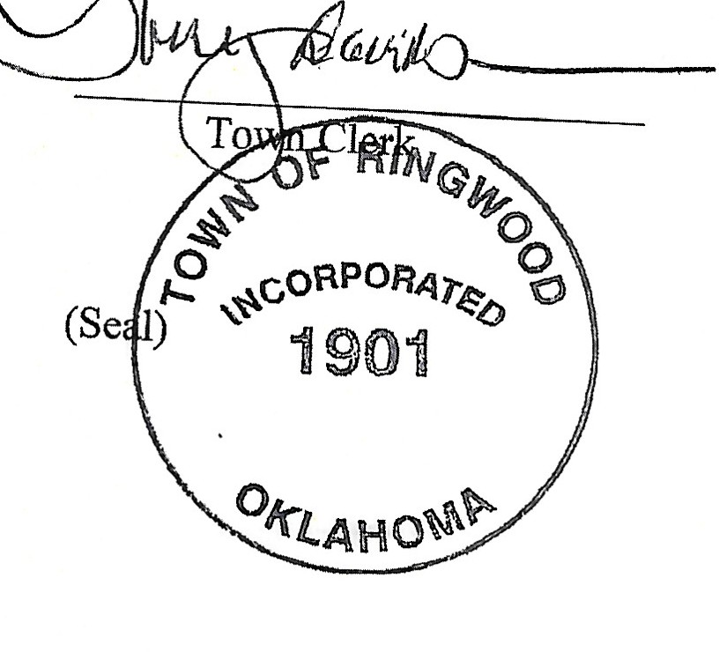
If the project is funded, the public will be notified of the completion of the project by conducting a public hearing at the closing out of the grant. This public hearing will be to invite citizens for input on the project according to the Citizens Participation Plan. All public comments were positive.

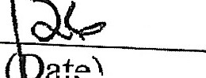
� (bate)

RINGWOOD TOWN COUNCIL
Regular Meeting - Ringwood Town Hall Monday, March 9. 2026
Immediately following Public Hearing Minutes
Page One

The meeting was called to order by Mayor Brandi Goodman at 5:45 p.m.

Members Present: Brandi Goodman, Gina Bohlen, Barbara Look , Sherry Davidson, Steve Randolph
Members Absent: Maxine Smith

Guest Present: Undersheriff Pate, Kayla Zook (MCSO), Steven Haldeman No public comments.
A motion was made by Gina Bohlen and seconded by Brandi Goodman approving the minutes of the February 9, 2026 regular meeting. The following votes were cast: Goodman - yes, Bohlen - yes, Look - yes, no nays.

TOWN CLERK/TREASURER REPORT: None CODE ENFORCEMENT: None
FIRE DEPARTMENT REPORT: None.
STREET DEPARTMENT REPORT: See attached report by Steve Randolph. SHERIFF DEPARTMENT : Undersheriff Pate provided the board with a report. NEW BUSINESS:
A motion was made by Gina Bohlen to approve the claims pursuant to the claims list.
Barbara Look seconded the motion and the following votes were cast: Bohlen - yes, Goodman - yes, Look -yes, no nays.
Bids were opened for the Main Street Asphalt Overlay Project REAP MA-26-2.
- Cummins Construction - $146,430.00
- Stan's Asphalt - $167,050.00
- Overland Corporation - No Bid received, Emailed information.
A motion was made by Brandi Goodman and seconded by Gina Bohlen to accept and approve the bid from Cummins Construction for $146,430.00. The following votes were cast: Goodman - yes, Bohlen - yes, Look - yes, no nays.

Page2
Ringwood Town Council
Monday, March 9, 2026 Regular Meeting Ringwood Town Hall

Steven Haldeman provided the board with an update on the security cameras that have been installed at the Fire Department and City Hall. He also discussed updating our copier to eliminate 3 other copiers that we currently have.

Gina Bohlen made a motion to sign and approve the interlocal agreement with Circuit Engineering District #8. Barbara Look seconded the motion and the following votes were cast: Bohlen - yes, Look - yes, Goodman - yes, no nays.
A motion was made by Barbara Look and seconded by Gina Bohlen to approve and sign the interlocal agreement with Major County Commissioners for 2026. The following votes were cast: Look - yes, Bohlen - yes, Goodman - yes, no nays.

Barbara Look made a motion to approve Resolution 2026-02 authorizing application to Oklahoma Department of Commerce for a CDBG Grant. Gina Bohlen seconded the motion and the following votes were cast: Look - yes, Bohlen - yes, Goodman -yes, no nays.
A motion was made by Gina Bohlen to allow Mareta Woodard-Parkhill to prepare, submit the FY 26 CDBG application for Walking Trail Project and administer if funded. Barbara Look seconded the motion and the following votes were cast: Bohlen - yes, Look - yes, Goodman - yes, no nays.
Brandi Goodman made a motion that was seconded by Gina Bohlen to approve Resolution 2026-03 approving leverage of funds for the FY2026 CDBG Grant application. The following votes were cast: Goodman - yes, Bohlen - yes, Look - yes, no nays.
A motion was made by Gina Bohlen to approve and sign the Town of Ringwood Citizens Participation Plan. Barbara Look seconded the motion and the following votes were cast: Bohlen -yes, Look -yes, Goodman - yes, no nays.
OTHER NEW BUSINESS:
Brandi Goodman made a motion that was seconded by Barbara Look to purchase a new copier/printer from HP for $1086.00. The following votes were cast: Goodman - yes, Look - yes, Bohlen - yes, no nays.

The meeting adjourned at 6:10 p.m.

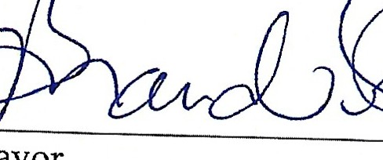
-�---"- ��
Mayor Clerk/Deputy Clerk

RINGWOOD PUBLIC WORKS AUTHORITY
Regular Meeting, Monday, March 9, 2026
200 N. Main, Ringwood, OK 73768
Page 1

Meeting called to order by Mayor Brandi Goodman at 6:10 p.m., City Hall.
ROLL CALL:
Brandi Goodman Gina Bohlen Barbara Look Sherry Davidson Steve Randolph

Members absent: Maxine Smith
Guest: Under Sheriff Pate, Steven Haldeman, Kayla Zook (MCSO) There were no public comments.
A motion was made by Gina Bohlen and seconded by Brandi Goodman to approve the minutes of the February 9, 2026 regular meeting. The following votes were cast: Goodman - yes, Bohlen -yes, Look -yes, no nays.

CLERK/TREASURER REPORT: None
PUBLIC WORKS REPORT: Steve Randolph presented his report. Please see attached. NEW BUSINESS:
Gina Bohlen made a motion to approve the claims as listed on the claims list. Barbara Look seconded
the motion and the following votes were cast: Goodman - yes, Bohlen - yes, Look - yes, no nays.
OTiiER NEW BUSINESS:
None
