RINGWOOD TOWN COUNCIL
Regular Meeting - Ringwood Town Hall Monday,June8,2026
5:30 p.m.
Minutes Page One

The meeting was called to order by Mayor Brandi Goodman at 6:15 p.m.

Members Present: Brandi Goodman, Gina Bohlen, Barbara Look , Sherry Davidson, Steve Randolph, Maxine Smith, Brandon Harmon
Guests: Undersheriff Pate, Kayla Zook, Susmita from NODA No public comments.
A motion was made by Barbara Look and seconded by Gina Bohlen approving the minutes of the May 4, 2026 regular meeting. The following votes were cast: Goodman-yes, Bohlen - yes, Look - yes, no nays.

TOWN CLERK/TREASURER REPORT: None
CODE ENFORCEMENT: Brian provided his report

FIRE DEPARTMENT REPORT: Brandon provided his report.
STREET DEPARTMENT REPORT: See attached report by Steve Randolph.
SHERIFF DEPARTMENT: Undersheriffreported that the tower grant has been received. They are now going out for bids.

NEW BUSINESS:
A motion was made by Gina Bohlen to approve the claims pursuant to the claims list. Barbara Look seconded the motion and the following votes were cast: Bohlen - yes, Goodman - yes, Look -yes, no nays.
Barbara Look made a motion that was seconded by Gina Bohlen to approve the Parkhill CDBG Administration Contract for #19839 CDBG 25-Walking and Hiking Trails. The following votes were cast: Look - yes, Bohlen - yes, Goodman - yes, no nays.
A motion was made by Gina Bohlen to approve the McDonald Engineering CDBG Contract for #19839 CDBG 25- New Walking and Hiking Trail. Barbara Look seconded the motion and the following votes were cast: Bohlen - yes, Look -yes, Goodman - yes, no nays.

Page2
Ringwood Town Council
Monday, June 8, 2026 Regular Meeting Ringwood Town Hall

Barbara Look made a motion that was seconded by Gina Bohlen to approve Resolution 2026-04 adopting Section 3 Plan for 19839 CDBG 25. The following votes were cast: Look -yes, Bohlen - yes, Goodman - yes, no nays.

A motion was made by Gina Bohlen and seconded by Barbara Look to approve the Fair Housing Resolution 2026-05. The following votes were cast: Bohlen-yes, Look-yes, Goodman - yes, no nays.

Gina Bohlen made a motion to approve the 2026 Fair House Proclamation. Barbara Look seconded the motion and the following votes were cast: Bohlen -yes, Look - yes, Goodman -yes, no nays.

A motion was made by Barbara Look to approve the Anti Displacement and Relocation Plan for #19839 CDBG 25. Gina Bohlen seconded the motion and the following votes were cast: Look - yes, Bohlen - yes, Goodman - yes, no nays.

Gina Bohlen made a motion that was seconded by Barbara Look to approve Resolution 2026-06 for #19839 CDBG 25 authorizing the Mayor to approve and sign invoices related to the new walking and hiking trail to expedite the process of CDBG funds draw down, with the understanding that said invoices will not be paid until the board approves the invoice in a formal meeting. The following votes were cast: Bohlen - yes, Look - yes, Goodman - yes, no nays.

A motion was made by Gina Bohlen to approve continuing medical insurance coverage for employees with OPEH &W Health Plan. Barbara Look seconded the motion and the following votes were cast: Bohlen - yes, Look - yes, Goodman - yes, no nays.

Sherry provided the board with an update on the new coffee shop. It will be called Valiant Coffee House and they are hoping for a soft opening in the middle of June.

Barbara Look made a motion to nominate Philip Schrahl to be the Town of Ringwood NODA representative for a two-year term. Gina Bohlen seconded the motion and the following votes were cast: Look - yes, Bohlen - yes, Goodman - yes, no nays.

Page3
Ringwood Town Council
Monday, June 8, 2026 Regular Meeting Ringwood Town Hall

OTHER NEW BUSINESS:
Sherry informed the board that she may be gone a few days due to the birth of her third grandbaby.

The meeting adjourned at 6:35 p.m.
�·�

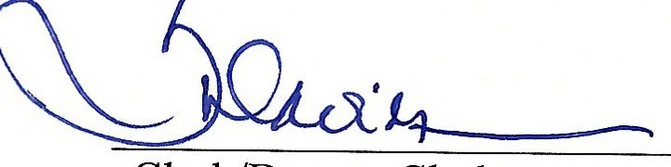
Mayor Clerk/Deputy Clerk

TOWN OF RINGWOOD MAJOR COUNTY, OKLAHOMA
LOCAL PLANNING ACTIVITIES COMMITTEE MEETING 200 N. MAIN, RINGWOOD, OKLA

Monday, June 8, 2026 5:30 p.m.

- Meeting called to order by Mayor Brandi Goodman.

- Members present: Brandi Goodman, Barbara Look, Gina Bohlen, Steve Randolph, Brandon Harmon, Sherry Davidson, Maxine Smith. Guests: Susmita from NODA, Undersheriff Pate, Kayla Zook

- A discussion was held regarding our Capital Improvement Plan and the needs and priorities of our community.

- Meeting adjourned at 6:15 p.m.

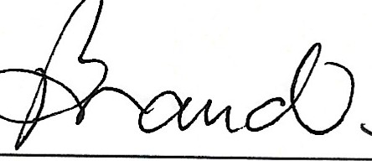
-M�a_y_o_r ���e_r_k

RINGWOOD PUBLIC WORKS AUTHORITY
Regular Meeting June 8, 2026
200 N. Main, Ringwood, OK 73768

Meeting called to order by Mayor Brandi Goodman at 6:35 p.m., City Hall.
ROLL CALL:
Brandi Goodman Gina Bohlen Barbara Look Maxine Smith Sherry Davidson Steve Randolph

Guests: None
There were no public comments.

A motion was made by Gina Bohlen and seconded by Barbara Look to approve the minutes of the May 4, 2026 regular meeting. The following votes were cast: Goodman - yes, Bohlen - yes, Look - yes, no nays.

CLERK/TREASURER REPORT: None
PUBLIC WORKS REPORT: Steve Randolph presented his report. Please see attached. NEW BUSINESS:
Barbara Look made a motion to approve the claims as listed on the claims list. Gina Bohlen seconded the motion and the following votes were cast: Goodman - yes, Bohlen - yes, Look - yes, no nays.
OTHER NEW BUSINESS:
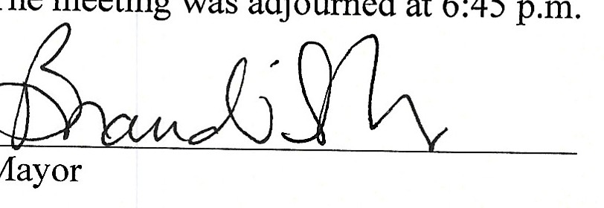
None

�'L!o--
Clerk/Deputy Clerk

