RINGWOOD TOWN COUNCIL
Regular Meeting - Ringwood Town Hall Monday, July 6, 2026
5:30 p.m.
Minutes Page One

The meeting was called to order by Mayor Brandi Goodman at 5:30 p.m.

Members Present: Brandi Goodman, Gina Bohlen, Barbara Look , Sherry Davidson, Steve Randolph, Brandon Harmon
Members Absent: Maxine Smith
Guests: Undersheriff Pate, Alex Mantz with OG&E No public comments.
A motion was made by Gina Bohlen and seconded by Barbara Look approving the minutes of the June 8, 2026 LPAC Meeting and the June 8, 2026 regular meeting. The following votes were cast: Goodman - yes, Bohlen - yes, Look - yes, no nays.
TOWN CLERK/TREASURER REPORT: None CODE ENFORCEMENT: None
FIRE DEPARTMENT REPORT: Brandon provided his report.

STREET DEPARTMENT REPORT: See attached report by Steve Randolph.

SHERIFF DEPARTMENT: Undersheriffreported that things have been quiet. They are still working on 911 and have managed to get 30% of the tax returned to Major County.

NEW BUSINESS:

A motion was made by Barbara Look to approve the claims pursuant to the claims list. Gina Bohlen seconded the motion and the following votes were cast: Bohlen - yes, Goodman - yes, Look -yes, no nays.

Gina Bohlen made a motion to approve the signing and application for the CENA Grant for the Ringwood Senior Citizens Center for FY26/27. Barbara Look seconded the motion and the following votes were cast: Bohlen - yes, Look - yes, Goodman - yes, no nays.

Page2
Ringwood Town Council
Monday, July 6, 2026 Regular Meeting Ringwood Town Hall

A motion was made by Gina Bohlen and seconded by Barbara Look to approve and sign the agreement with Cummins Construction Company for the REAP Grant Asphalt Overlay Project. The following votes were cast: Bohlen - yes, Look - yes, Goodman - yes, no nays.

Alex Mantz from OG&E had a presentation for the board regarding our upcoming renewal of the OG&E Franchise Agreement. This agreement is renewable every 25 years. We will need to renew the agreement in 2027.

Barbara Look made a motion to approve the ditch repairs to W. County Rd. The project will be completed by Schmidt Dirtworks. His bid was for $3500.00. Gina Bohlen seconded the motion and the following votes were cast: Look -yes, Bohlen - yes, Goodman - yes, no nays.

OTHER NEW BUSINESS:
Sherry notified the board of a design meeting tomorrow at 3:30 pm with Ryan McDonald of McDonald Engineering on the Walking Trail project.

The meeting adjourned at 5:55 p.m.

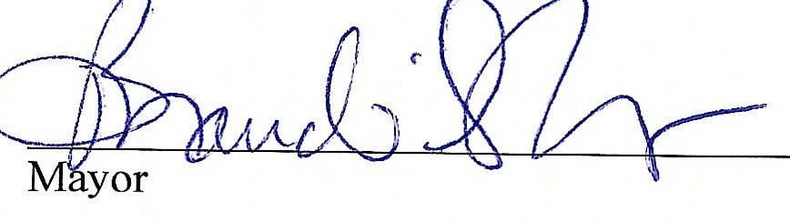
�:.io---
Clerk/Deputy Clerk

RINGWOOD PUBLIC WORKS AUTHORITY
Regular Meeting July 6, 2026
200 N. Main, Ringwood, OK 73768

Meeting called to order by Mayor Brandi Goodman at 5:56 p.m., City Hall.
ROLL CALL:
Brandi Goodman Gina Bohlen Barbara Look Brandon Harmon Sherry Davidson Steve Randolph Undersheriff J. Pate

Members absent: Maxine Smith There were no public comments.
A motion was made by Gina Bohlen and seconded by Barbara Look to approve the minutes of the June 8, 2026 regular meeting. The following votes were cast: Goodman - yes, Bohlen - yes, Look - yes, no nays.

CLERK/TREASURER REPORT: None

PUBLIC WORKS REPORT: Steve Randolph presented his report. Please see attached.
NEW BUSINESS:
Barbara Look made a motion to approve the claims as listed on the claims list. Gina Bohlen seconded the motion and the following votes were cast: Goodman - yes, Bohlen - yes, Look - yes, no nays.

OTHER NEW BUSINESS:
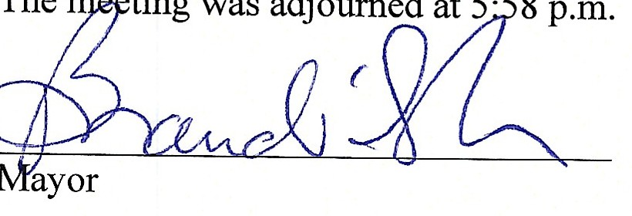
None
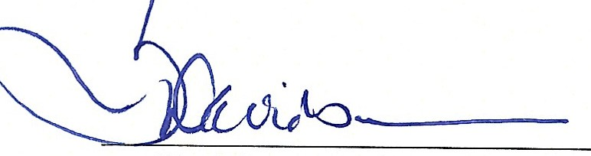
Clerk/Deputy Clerk

