RINGWOOD TOWN COUNCIL
Regular Meeting - Ringwood Town Hall Monday, January 5, 2026
5:30 p.m.
Minutes Page One

The meeting was called to order by Mayor Brandi Goodman at 5:30 p.m.
Members Present: Brandi Goodman, Gina Bohlen, Barbara Look , Sherry Davidson, Steve Randolph, Brandon Harmon
Members Absent: Maxine Smith

Guest Present: Deputy Palato, Maverick No public comments.
A motion was made by Barbara Look and seconded by Gina Bohlen approving the minutes of the December 5, 2025 special meeting and the December 8, 2025 regular meeting. The following votes were cast: Goodman - yes, Bohlen - yes, Look - yes, no nays.

TOWN CLERK/TREASURER REPORT: None CODE ENFORCEMENT: None
FIRE DEPARTMENT REPORT: Brandon Harmon provided the board with a report. STREET DEPARTMENT REPORT: See attached report by Steve Randolph.
SHERIFF DEPARTMENT: Deputy Palato provided the board with a report. NEW BUSINESS:
A motion was made by Gina Bohlen to approve the claims pursuant to the claims list. Barbara Look seconded the motion and the following votes were cast: Bohlen - yes, Goodman - yes, Look - yes, no nays.

Gina Bohlen made a motion that was seconded by Barbara Look approving Resolution 2025-09 authorizing OMAG to distribute escrow account funds. The following votes were cast: Bohlen - yes, Look -yes, Goodman - yes, no nays.

Page2
Ringwood Town Council
Monday, January 5, 2026 Regular Meeting Ringwood Town Hall

A motion was made by Barbara Look to approve the annual renewal of the Major County Sheriff Contract. Gina Bohlen seconded the motion and the following votes were cast: Look - yes, Bohlen - yes, Goodman - yes, no nays.

Gina Bohlen made a motion that was seconded by Barbara Look to approve Sherry Davidson as voting delegate and Steve Randolph as alternate delegate for ORWA. The following votes were cast: Bohlen - yes, Look - yes, Goodman - yes, no nays.

A discussion was held regarding our rental at 211 N. Main. Be Coffee has until January 10, 2026 to vacate the property. If no action is taken, we will continue with legal action.

Sherry provided the board with an update on information she received on the walking trails. She will speak with Ildefonso Rojas and see if he is interested in selling his lot to allow us a better entrance into the area.

A discussion was held regarding our annual year in review letter. Sherry will be working on the letter and will provide the board with the letter for approval at our next meeting.

OTHER NEW BUSINESS:

None

The meeting adjourned at 6:13 p.m.
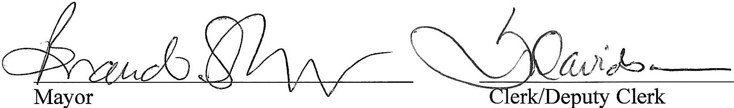

RINGWOOD PUBLIC WORKS AUTHORITY
Regular Meeting, Monday, January 5, 2026
200 N. Main, Ringwood, OK 73768
Page 1

Meeting called to order by Mayor Brandi Goodman at 6:14 p.m., City Hall.

ROLL CALL:
Brandi Goodman Gina Bohlen Barbara Look Sherry Davidson Steve Randolph Brandon Harmon
Members absent: Maxine Smith Guest: Deputy Palato, Maverick

There were no public comments.

A motion was made by Gina Bohlen and seconded by Barbara Look to approve the minutes of the December 8, 2025 regular meeting. The following votes were cast: Goodman - yes, Bohlen - yes, Look - yes, no nays.
CLERK/TREASURER REPORT: None
PUBLIC WORKS REPORT: Steve Randolph presented his report. Please see attached. NEW BUSINESS:
Gina Bohlen made a motion to approve the claims as listed on the claims list. Barbara Look seconded
the motion and the following votes were cast: Goodman - yes, Bohlen - yes, Look - yes, no nays.

Sherry provided the board with letter from Waste Connections that our trash rates will be increasing 2.74% in February. We will see the increase on our March statement.

Sherry updated the board on the new QR code on our statements. We have had an increased online participation with the new code.

A discussion was held regarding rate increases for water, sewer, and trash for 2026. Sherry will have a resolution at our next meeting for approval.

RINGWOOD PUBLIC WORKS AUTHORITY
Regular Meeting, Monday, January 5, 2026
200 N. Main, Ringwood, OK 73768
Page 2

OTHER NEW BUSINESS:

None

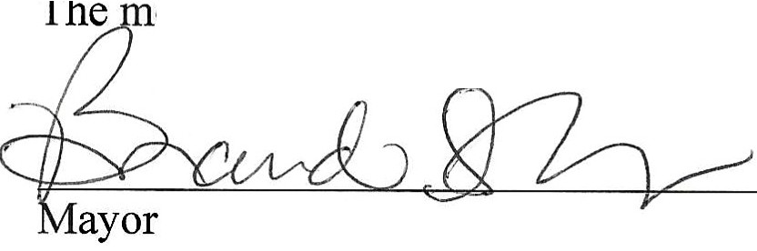
��do--
eeting was adjourned at 6:50 p.m.
Clerk/Deputy Clerk

