Ringwood Town Council Special Board Meeting Minutes Friday, Decemher 5, 2025
265137 E. County Rd 47, Ringwood, OK 6:30 p.m.
The special meeting was called to order at 6:30 p.m. by Mayor Brandi Goodman.

Members present: Brandi Goodman, Barbara Look, Sherry Davidson, Gina Bohlen, Steve Randolph

Members absent: Maxine Smith

Guests present: Dustin Goodman, Mark Davidson, Doug Bohlen, Michelle Randolph

The annual Town of Ringwood Holiday party commenced. The meeting adjourned at 9:00 p.m.

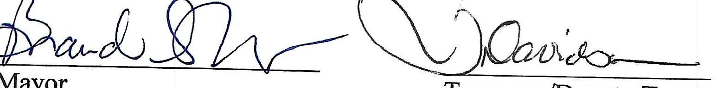
Mayor Treasurer/Deputy Treasurer

RINGWOOD TOWN COUNCIL
Regular Meeting - Ringwood Town Hall Monday, December 8, 2025
5:30 p.m.
Minutes Page One
The meeting was called to order by Mayor Brandi Goodman at 5:30 p.m.

Members Present: Brandi Goodman, Gina Bohlen, Barbara Look , Sherry Davidson, Steve Randolph, Brandon Harmon, Maxine Smith

Guest Present: Undersheriff Pate, MCSO No public comments.
A motion was made by Gina Bohlen and seconded by Barbara Look approving the minutes of the November 3, 2025 regular meeting. The following votes were cast: Goodman -yes, Bohlen - yes, Look - yes, no nays.
TOWN CLERK/TREASURER REPORT: None
CODE ENFORCEMENT: Sherry reported that Brian has performed the Life Safety Inspections. She has mailed out the reports to each business for review. The next steps were discussed and Sherry will talk to Brian regarding penalties, etc.
FIRE DEPARTMENT REPORT: Brandon Harmon provided the board with a report. STREET DEPARTMENT REPORT: See attached report by Steve Randolph.
SHERIFF DEPARTMENT: Undersheriff Pate provided the board with a report. NEW BUSINESS:
A motion was made by Barbara Look to approve the claims pursuant to the claims list. Gina Bohlen seconded the motion and the following votes were cast: Bohlen - yes, Goodman - yes, Look - yes, no nays.
Brandi Goodman made a motion to approve the 2026 Town of Ringwood Town Meeting dates. Gina Bohlen seconded the motion and the following votes were cast: Goodman - yes, Bohlen -yes, Look - yes, no nays.

Page2
Ringwood Town Council
Monday, December 8 , 2025 Regular Meeting Ringwood Town Hall

A motion was made by Brandi Goodman and seconded by Gina Bohlen to approve Ordinance 2025-03 authorizing the pass-through of inspection fees incurred during construction projects, providing for definitions, fee structure, administration, severability, and an effective date. The following votes were cast: Goodman -yes, Bohlen - yes, Look
- yes, no nays,
Gina Bohlen made a motion to approve a letter of termination oflease to Brock Bishop dba Be Coffee. Barbara Look seconded the motion and the following votes were cast: Bohlen - yes, Look- yes, Goodman -yes, no nays.

A motion was made by Brandi Goodman to approve and update the Town of Ringwood Fire and Life Safety policy. Gina Bohlen seconded the motion and the following votes were cast: Goodman -yes, Bohlen - yes, Look - yes, no nays.
Sherry provided the board with an update on the land donation. The deed has been filed with the county and the property now officially belongs to the Town of Ringwood.

Gina Bohlen made a motion that was seconded by Barbara Look to approve Ordinance 2025-04 amending Chapter 2, Article 6, of the Ringwood Municipal Code 2024 by the adoption of an amended Article 6 entitled "Town Records"; providing for Section 2-601 entitled "Purpose"; providing for Section 2-602 entitled "Statement of Policy"; providing for Section 2-603 entitled "Appointment of Open Record and Record Retention Custodians"; Providing for Section 2-604 entitled "Open Record Requests"; providing for Section 2-605 entitled "Processing Record Requests'; providing for Section 2-606 entitled "Scope of Record Search"; providing for Section 2-607 entitled "Records in Storage"; providing for Section 2-608 entitled "Computer Records"; providing for Section 2-609 entitled "Fees for Records"; providing for Section 2-610 entitled "Accountability of Funds"; providing for Section 2-611 entitled "Open Records Form Adopted"; providing for Section 2-612 entitled "Legal Questions"; providing for Section 2-613 entitled "Destruction of Public Records; Scanning and Storing Public Records"; providing for the repealer of the current section 2-601 through 2-614 and Sections 2-609 and 2-611 in Chapter 18 entitled "Fee Schedule"; providing for savings; providing for codification; providing for severability ;and declaring an emergency. The following votes were cast: Bohlen - yes, Look - yes, Goodman -yes, no nays.

At this time, 6:23 p.m., Gina Bohlen made a motion that was seconded by Barbara Look to enter into executive session to discuss Town of Ringwood employee Christmas bonuses for 2025 pursuant to O.S. Title 25, Section 307 (b) 1. And review priorities with respect to each and reconvene into regular session to take action thereof The following votes were cast: Bohlen - yes, Look -yes, Goodman - yes, no nays.

Page 3
Ringwood Town Council
Monday, December 8, 2025 Regular Meeting Ringwood Town Hall

At this time, 6:23 p.m., the board retired into executive session.
At this time, 6:25 p.m., a motion was made by Gina Bohlen to return to regular session. Barbara Look seconded the motion and the following votes were cast: Bohlen -yes, Look
- yes, Goodman - yes, no nays.

At this time, 6:25 p.m., the board returned to regular session.

Brandi Goodman made a motion to approve a $600.00 Christmas Bonus for Steve Randolph and Sherry Davidson. Gina Bohlen seconded the motion and the following votes were cast: Goodman -yes, Bohlen -yes, Look - yes, no nays.

OTHER NEW BUSINESS:
Sherry informed the board that the Town of Ringwood has been awarded a CDBG Grant to update the Capital Improvement Plan for the Town of Ringwood. The grant award is
$20,000.00

Sherry asked the board permission to gift a $100.00 Richard's Food Store Gift Card to Staci Wanzer for all of her volunteer work at the Senior Citizens Center. The board thought it would be a great idea.
A discussion was held regarding "The Woods" subdivision. Sherry is waiting on Porterfield to send an updated Preliminary Plat for us to sign.

The meeting adjourned at 6:32 p.m.
�LJ���--

Mayor � Clerk/Deputy Clerk

RINGWOOD PUBLIC WORKS AUTHORITY
Regular Meeting, Monday, December 8, 2025
200 N. Main, Ringwood, OK 73768

Meeting called to order by Mayor Brandi Goodman at 6:32 p.m., City Hall.
ROLL CALL:
Brandi Goodman Gina Bohlen Barbara Look Sherry Davidson Steve Randolph Brandon Harmon
Members absent: Maxine Smith Guest: Undersheriff Pate, MCSO

There were no public comments.
A motion was made by Barbara Look and seconded by Gina Bohlen to approve the minutes of the November 3, 2025 regular meeting. The following votes were cast: Goodman - yes, Bohlen -yes, Look - yes, no nays.
CLERK/TREASURER REPORT: None
PUBLIC WORKS REPORT: Steve Randolph presented his report. Please see attached. NEW BUSINESS:
Brandi Goodman made a motion to approve the claims as listed on the claims list. Barbara Look seconded the motion and the following votes were cast: Goodman - yes, Bohlen - yes, Look -yes, no nays.

Sherry provided the board with a report outlining other communities in our area and what they charge for water and sewer. We will be revisiting our rates after the first of the year due to increases on trash.

OTHER NEW BUSINESS:

None

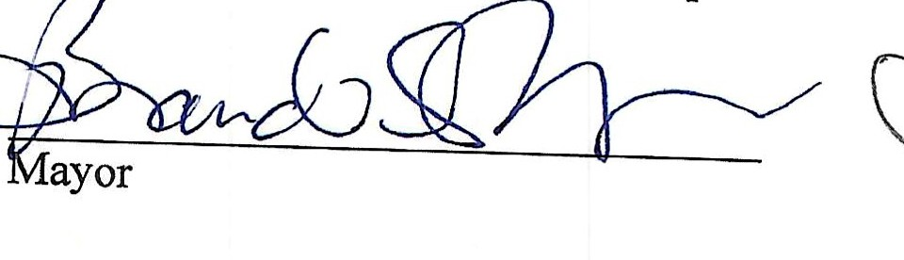 �� �k/Deputy Clerk

