TOWN OF RINGWOOD MAJOR COUNTY, OKLAHOMA
TOWN OF RINGWOOD
PLANNING AND ZONING COMMITTEE PUBLIC HEARING MONDAY, AUGUST 10, 2026 AT 5:30 PM., CITY HALL

Meeting called to order by Mayor Brandi Goodman at 5:30 p.m.

Members present were: Brandi Goodman, Gina Bohlen, Barbara Look, Sherry Davidson, Brandon Harmon, Steve Randolph, Maxine Smith

Guests present: Taly Espinoza & family, Alex Mantz, Ryan McDonald, Undersheriff Pate, Depurty Randy Wilson

A discussion was held regarding the possible placement of a residential modular home on Chestnut Street. Mrs. Espinoza had also asked about placement in the Crossroads Estates Addition. However, the covenants for the Crossroads Estates Addition do not allow these type of homes.

Brandi Goodman made a motion to make a recommendation to the Board of Trustees of the Town of Ringwood that the home be allowed to be placed on Chestnut Street.
Barbara Look seconded the motion and the following votes were cast: Goodman - yes, Look - yes, Bohlen - yes, no nays.

Meeting adjourned at 5:45 pm.
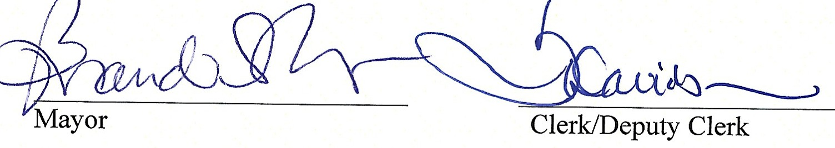

RINGWOOD TOWN COUNCIL
Regular Meeting - Ringwood Town Hall Monday, August 10, 2026
Immediately following the Planning and Zoning Meeting Minutes
Page One

The meeting was called to order by Mayor Brandi Goodman at 5:45 p.m.

Members Present: Brandi Goodman, Gina Bohlen, Barbara Look , Sherry Davidson, Steve Randolph, Brandon Harmon, Maxine Smith
Guests: Undersheriff Pate, Alex Mantz with OG&E, Ryan McDonald, Deputy Randy Wilson

No public comments.

A motion was made by Gina Bohlen and seconded by Barbara Look approving the minutes of the July 6, 2026 regular meeting. The following votes were cast: Goodman - yes, Bohlen - yes, Look - yes, no nays.

TOWN CLERK/TREASURER REPORT: None

CODE ENFORCEMENT: Brian provided a report. Pool enclosures were discussed. FIRE DEPARTMENT REPORT: Brandon provided his report.
STREET DEPARTMENT REPORT: See attached report by Steve Randolph.

SHERIFF DEPARTMENT: Undesheriff Pate introduced the board to Deputy Randall Wilson. He will be our contact for law enforcement. Deputy Wilson provided a report for the board regarding 911 calls made last month.
NEW BUSINESS:

A motion was made by Barbara Look to approve the claims pursuant to the claims list. Gina Bohlen seconded the motion and the following votes were cast: Bohlen - yes, Goodman - yes, Look -yes, no nays.

Gina Bohlen made a motion that was seconded by Barbara Look to move the regular town council meeting from Monday, September 7th to a special meeting on Tuesday, September 8th, 2026 due to the Labor Day Holiday. The following votes were cast: Bohlen - yes, Look - yes, Goodman - yes, no nays.

Page2
Ringwood Town Council
Monday, August 10, 2026 Regular Meeting Ringwood Town Hall

A motion was made by Barbara Look to sign and approve the annual contract with the Major County Sheriffs Office. Gina Bohlen seconded the motion and the following votes were cast: Look - yes, Bohlen - yes, Goodman - yes, no nays.

Gina Bohlen made a motion that was seconded by Barbara Look to approve and sign the engagement letter with S&B CPA's & Associates to perform the agreed upon procedures required by Oklahoma Statutes. The following votes were cast: Bohlen - yes, Look - yes, Goodman - yes, no nays.

A motion was made by Brandi Goodman to adopt Ordinance #2026-2 Opting out of the Oklahoma Town Meeting Act. Barbara Look seconded the motion and the following votes were cast: Goodman - yes, Look - yes, Bohlen - yes, no nays.

Gina Bohlen made a motion to adopt Ordinance #2026-3 granting to Oklahoma Gas & Electric Company a franchise for the installation, operation, and maintenance of an electric distribution system in the Town of Ringwood and the selling of electricity therein for a term of 25 years. Barbara Look seconded the motion and the following votes were cast: Bohlen - yes, Look - yes, Goodman -yes, no nays.
A motion was made by Gina Bohlen and seconded by Barbara Look to adopt Resolution 2026-5 calling and holding an election in the Town of Ringwood for the purpose of granting a franchise to Oklahoma Gas & Electric for the installation, operation and maintenance of an electric distribution system and the selling of electricity therein for a term of 25 years. The following votes were cast: Bohlen - yes, Look - yes, Goodman - yes, no nays.
A discussion was held with Ryan McDonald regarding the Walking Trail Project.
Barbara Look made a motion to accept and approve the recommendation made by The Planning and Zoning Committee to allow the modular home to be placed on Chestnut Street. Gina Bohlen seconded the motion and the following votes were cast: Look - yes, Bohlen - yes, Goodman - yes, no nays.

Page3
Ringwood Town Council
Monday, August 10, 2026 Regular Meeting Ringwood Town Hall

OTHER NEW BUSINESS:

Sherry informed the board that we have again received the CENA Grant for the Senior Citizens Center.

NODA is holding the mandatory REAP Grant Application Meeting on August 20th. Sherry will be on vacation but she will attend via her phone.

The meeting adjourned at 6:30 p.m.

���� 2
� Clerk/Deputy Clerk

RINGWOOD PUBLIC WORKS AUTHORITY
Regular Meeting August 10, 2026
200 N. Main, Ringwood, OK 73768

Meeting called to order by Mayor Brandi Goodman at 6:45 p.m., City Hall.

ROLL CALL:
Brandi Goodman Gina Bohlen Barbara Look Sherry Davidson Maxine Smith

Members absent: Steve Randolph There were no public comments.
A motion was made by Barbara Look and seconded by Gina Bohlen to approve the minutes of the July 6, 2026 regular meeting. The following votes were cast: Goodman - yes, Bohlen - yes, Look - yes, no nays.
CLERK/TREASURER REPORT: None
PUBLIC WORKS REPORT: Steve Randolph presented his report. Please see attached. NEW BUSINESS:
Gina Bohlen made a motion to approve the claims as listed on the claims list. Barbara Look seconded
the motion and the following votes were cast: Goodman - yes, Bohlen - yes, Look - yes, no nays.
Discussion was tabled regarding the DEQ Inspection due to Steve being absent. We will discuss next month.

OTHER NEW BUSINESS:
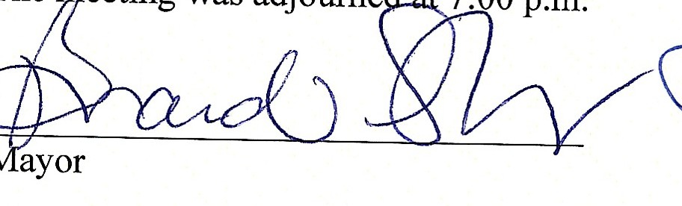
None

�{P --.
Clerk/Deputy Clerk

