RINGWOOD TOWN COUNCIL
Regular Meeting - Ringwood Town Hall Tuesday, April 7, 2026
5:30 p.m.
Minutes Page One

The meeting was called to order by Mayor Brandi Goodman at 5:30 p.m.

Members Present: Brandi Goodman, Gina Bohlen, Barbara Look , Sherry Davidson, Steve Randolph
Members Absent: Maxine Smith No public comments.
A motion was made by Gina Bohlen and seconded by Barbara Look approving the minutes of the March 9, 2026 Public Hearing and regular meeting. The following votes were cast: Goodman - yes, Bohlen - yes, Look - yes, no nays.
TOWN CLERK/TREASURER REPORT: None CODE ENFORCEMENT: None
FIRE DEPARTMENT REPORT: None.

STREET DEPARTMENT REPORT: See attached report by Steve Randolph. SHERIFF DEPARTMENT: None.
NEW BUSINESS:

A motion was made by Barbara Look to approve the claims pursuant to the claims list. Gina Bohlen seconded the motion and the following votes were cast: Bohlen - yes, Goodman - yes, Look -yes, no nays.
A discussion was held regarding the Town Rental property at 211 N. Main. Sherry did have an individual contact her asking if the Town would consider selling the property. The board would like to keep the building and suggest renting to the individual first. No action taken.

Brandi Goodman made a motion that was seconded by Gina Bohlen to approve the transfer of$1500.00 from General Government, M & 0 to General Government, Managerial for end of year expenses. The following votes were cast: Goodman - yes, Bohlen - yes, Look - yes, no nays.

Page2
Ringwood Town Council
Tuesday, April 7, 2026 Regular Meeting Ringwood Town Hall

A motion was made by Brandi Goodman and seconded by Barbara Look to offer Ildefonso Rojas $5000.00 for the purchase of property at North Main. It will cost the Town to update or create an abstract and also get a title opinion as suggested by our attorney. The following votes were cast : Goodman - yes, Look - yes, Bohlen - yes, no nays.

A discussion was held regarding the increase in our property insurance premium from OMAG. The increase will become effective in February of 2027. The trustees would like for Sherry to check on what the premium would be after lowering some of the appraised property values. She will get back with the board at our next meeting.

A discussion was held regarding the future walking trails. A workday was discussed. Sherry will check with property owners around the area to get permission to park and use drives to access our property. Steve will begin clearing dead trees, etc. We also discussed names for the trails. Everyone will get back with ideas at our next meeting.

OTHER NEW BUSINESS:
Gina Bohlen made a motion to approve the signing of the purchase order #204 to NODA for GPS updates, etc. for the CDBG CIP Grant. Barbara Look seconded the motion and the following votes were cast: Bohlen - yes, Look - yes, Goodman - yes, no nays.

Sherry informed the board that rolloffs have been scheduled for May I I-15th. The meeting adjourned at 6:40 p.m.
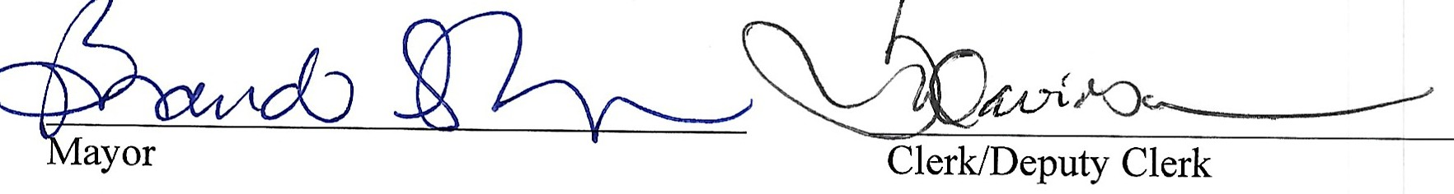

RINGWOOD PUBLIC WORKS AUTHORITY
Regular Meeting, Tuesday, April 7, 2026
200 N. Main, Ringwood, OK 73768
Page 1

Meeting called to order by Mayor Brandi Goodman at 6:40 p.m., City Hall.
ROLL CALL:
Brandi Goodman Gina Bohlen Barbara Look Sherry Davidson Steve Randolph

Members absent: Maxine Smith There were no public comments.
A motion was made by Barbara Look and seconded by Gina Bohlen to approve the minutes of the March 9, 2026 regular meeting. The following votes were cast: Goodman - yes, Bohlen-yes, Look - yes, no nays.

CLERK/TREASURER REPORT: None
PUBLIC WORKS REPORT: Steve Randolph presented his report. Please see attached. NEW BUSINESS:
Gina Bohlen made a motion to approve the claims as listed on the claims list. Barbara Look seconded the motion and the following votes were cast: Goodman - yes, Bohlen - yes, Look - yes, no nays.

OTHER NEW BUSINESS:
None

The meeting was adjourned at 6:45 p.m.
�Ju:Ib---��--........
Mayor Clerk/Deputy Clerk

